GAZEBO

What is gazebo ?
Gazebo is an open-source 3D robotics simulator.Gazebo integrated the ODE physics engine, OpenGL rendering, and support code for sensor simulation and actuator control.
A well-designed simulator makes it possible to rapidly test algorithms, design robots, perform regression testing, and train AI System using realistic scenarios. Gazebo offers the ability to accurately and efficiently simulate populations of robots in complex indoor and outdoor environments.

Uses-
- It makes possible to rapidly test algorithms, design robots, perform regression testing, and train AI system using realistic scenarios.
-Gazebo can use multiple high-performance physics engines, such as ODE, Bullet.
-It can model sensors that "see" the simulated environment, such as Laser range finders cameras (including wide-angle), Kinect style sensors.

Installing Gazebo:
Before starting, we have to make sure that we have gazebo installed. Gazebo originally comes with the ROS Distro.
- To confirm that you already have it installed, type the command
$ gazebo --version
In the command prompt, and check if it shows a version.
- Try the command
$ gazebo
This should open a new world.
- Let’s get familiar with gazebo by launching ‘husky’ simulator. Type

$ sudo apt-get install ros-melodic-husky-simulator
If you are running on the ubuntu 18.04 system.
- Setup an environment variable, any name will suffice(eg: HUSKY_GAZEBO_DESCRIPTION) by typing
$ export HUSKY_GAZEBO_DESCRIPTION=$(rospack find husky_gazebo)/urdf/description.gazebo.xacro
Followed by
$ roslaunch husky_gazebo husky_playpen.launch
Which will launch a world, with a husky robot at the centre.
- For controls of husky, we will need to use teleop_twist_keyboard. For this type
$ git clone https://github.com/ros-teleop/teleop_twist_keyboard.git
$ cd ..
$ catkin_make
$ source devel/setup.bash
In src directory
- Type
$ rosrun teleop_twist_keyboard teleop_twist_keyboard.py
And then you can start with controlling the husky robot on gazebo.

USING GAZEBO:
- Once you have finished running the above commands, you will see the below screen:
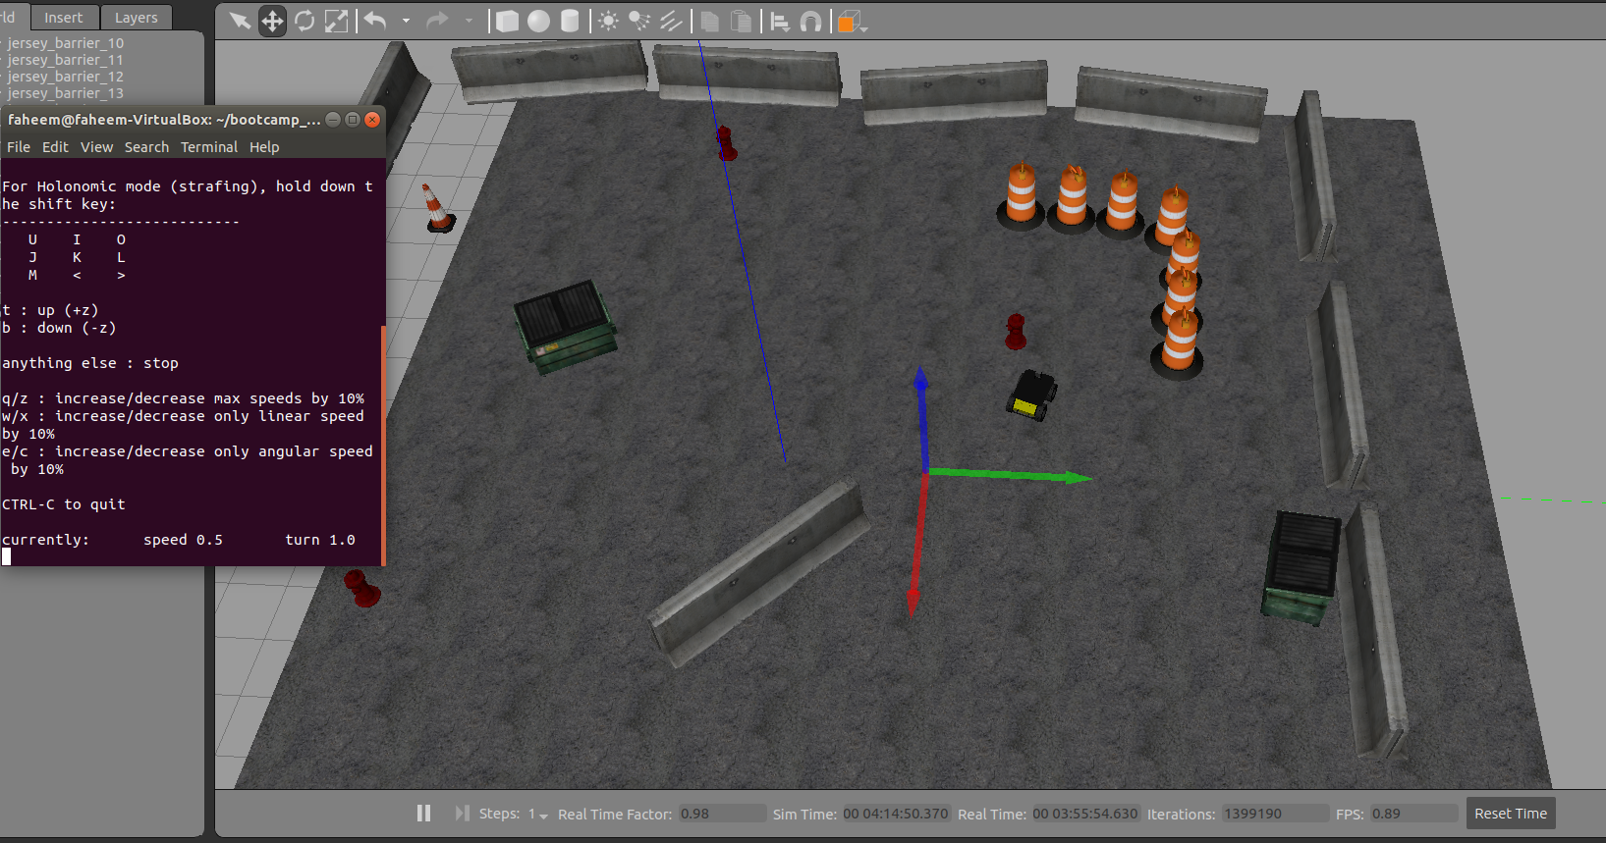
- Navigate gazebo, use the options in the intended ways:
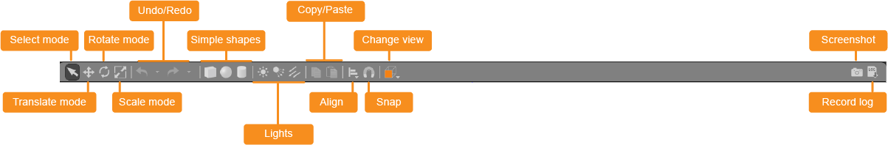
Function of different buttons in gazebo:
- Select mode: Navigate in the scene
- Translate mode: select models you want to move
- Rotate mode: select models you want to rotate
- Scale mode:select models you want to scale
- undo/redo: Undo/ redo actions in the scene
- Simple shapes: Insert simple shapes into the scene
- copy/paste: Copy/paste models in the scene
- Align: Align models to one another
- Change view: View the scene from various angles

GAZEBO in working: